Recommendations for a general Event message
Version 1.0

IT & Telecom Agency
January 2010
Contents
Contents 2
Introduction 3
Recommended Use 3
Background 3
Process 3
Description of content 3
Chapter 1: Objectives and Principles 4
What is a general event message maps? 4
Objectives and Principles 4
Chapter 2 Process integration with events 5
Use of incidents loose coupling 5
Concepts 6
Usage scenario 9
Chapter 3 WSI-SD - Ringsted Project 11
Format of the event message - EventStructure 11
Chapter 4 International standards 12
Web Services Notification (WSN) 12
Format of the event message 12
Webservices Eventing (WSE) 12
Format of the event message 12
Chapter 5 A general event message 14
Use of the message format along with WS-Eventing or WS-Notification 16
Examples 16
References 20
Appendix A – XML Schema for WSN 22
Appendix B - Proposed XML Schema for WSE 24
Appendix C - Proposal by [Haendelse08] 25

Introduction
This document is a draft recommendation for a general event message.

Recommended Use
Message format defined in this document may be used generally to transfer events on a uniform way, aiming for an overall messaging interoperability.
Document-based messaging and web services today have no disclosure in the public sector, while the process integration with the incident is still new to most with the exception of some sectors and problem areas.
This can be expressed as the ripeness in this area yet not so great. Document area expected events, however, becoming an important element towards the realization of the reference architecture, which will be contributed to an increased maturity.

Background
Given a web service pilot project for the Integration of Proceedings and Documents (WSI-SD) [WSISD] was there in the spring of 2008 produced a consultation draft for the standardization of a general event message. The proposal for standardization of event message was not approved by the OIO Board, who missed an illustration of its relationships with international standards. Instead it was decided that there should be an open OIO process involving relevant national and international experience, and that this would culminate in a revised proposal for the standardization of general event message to be sent in consultation and treatment in OIO Board by the end of 2009.

Process
The initial draft has been held up to international standards that exist for general event messages. There was before the summer held a half-day workshop, from which it was decided that the international standards had no separate value. Why should the existing draft adapted to requirements to date have come out of the standardization of Case & Document? There have been searched for similar formats already in use, but this has not been the case.

Description of content
This document contains a chapter that briefly describes what a general event message is for a size and the principles underlying the election. Chapter two is a brief introduction to integration with incidents, and defines basic concepts and general scenarios. The third chapter briefly describes the general event message that was in the original consultation draft "Event - Semantics and Schedule "[Haendelse08]. The fourth chapter describes the parts of the relevant international standards that can be used in relation to a general event message, and chapter five describes the recommended format which is also realized in forms available on digitaliser.dk. Last follows a list of relevant references and in the following appendix a short form xml description of international candidates.

Chapter 1: Objectives and Principles

What is a general event message maps?
A general event message is a message format (message) that can be used when transferring events between IT systems. The general means that it can be used broadly to all incidents regardless of discipline, sector or specific incident. The general event message functions primarily as a part of infrastructure and is located in the boundary layer between the specific incident message (the actual business and transport layer (addressing, protocol and wire format), as shown in Figure 1 below:
Specific event message
General Event Message
Transportation
Figure 1
This allows a customer to immediately receive a variety of events without having support for specific formats, and can thus simplify the interface and used for a comprehensive content-based routing.

Objectives and Principles
A general event must meet the following objectives:
- Must be used generally for all events regardless of discipline, sector or specific incident
- Must be easy to understand and use / transportation
- Must be independent of the exchange protocol
- Must be able to provide value in more complex technical architectures without making it unnecessarily complex for simple architectures (topologies)
- Must support that specific event messages can be both very simple or complex
- It should be possible to ensure the integrity of the producer to receive
- Must be able to use whatever method of authentication or authorization.
Conversely, the following is NOT a goal:
- Appointment of a technical protocol (OIORASP, OWSA ModelT etc.).
- Choice of subscription management, creation, maintenance, including subscription expression
- Appointment of syntax for subscription term or topic breakdown
- Appointment of event / notification default wide
- Push vs. Pull
- The content of the specific event messages, and possibly standardization and generalization in sectors and domains
- Establishment of the taxonomy of event types, topics, and similar
- Guide to assessment of suitable events
- Replace the message formats are included with most messaging / transport protocols such. JMS, JMS,
- MSMQ, AMQP osv. MSMQ, AMQP, etc
- Replace existing management protocols such. Simple Network Management Protocol Simple Network Management Protocol (SNMP). Focus on business events.

Chapter 2 Process integration with events
There are a quantity of literature and articles that describe event-based architecture (Event-Driven Architecture) in depth. This is just a brief description. Enterprise Integration The widely used book Enterprise Integration Patterns [EIP] describes the relevant patterns, including incidents (events).
Below describes briefly how the integration of events can create a coherent and while loosely coupled architecture. Then define the key concepts and end gives a basic scenario for the use of a general event message.

Use of incidents loose coupling
Workflows are connected but undertaken independently of each other can be usefully integrated with events. Workflows typically have a longer life, are usually conducted as a series of successive process steps, where the end of one process step starts the next. This can be technically achieved by to describe the completion of a process step with an event message (which may be regarded as a data communications are carried forward and start the next process step. Characteristic of event-based integration is that there is no centralized control of total flow, once it has been designed and implemented. It must of course be monitored to ensure that it runs properly and as expected.
An example of such integration can be seen in the reference architecture for Case & Document [SDREFARK].
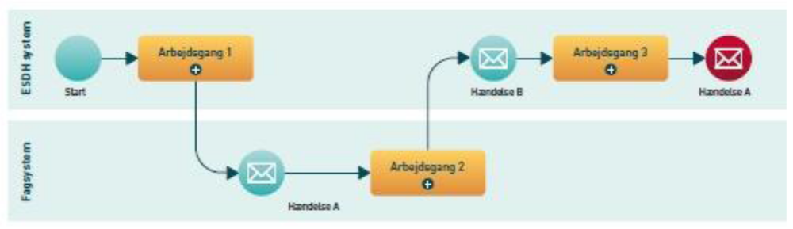
Figure 2 Process Integration with events (from Figure 17 from [SDREFARK])
All of the reference architecture for Action & document is largely based on the integration between the processes through events. Reference to BPMN's Definition (afnit "9.3 Events" in [BPMN11]) covering wide:
“An Event is something that “happens” during the course of a business process. These Events affect the flow of the Process and usually have a cause or an impact. The term “event” is general enough to cover many things in a business process. The start of an activity, the end of an activity, the change of state of a document, a message that arrives, etc., all could be considered events. However, BPMN has restricted the use of events to include only those types of events that will affect the sequence or timing of activities of a process. BPMN further categorizes Events into three main types: Start, Intermediate, and End.”
Note: Regardless of the architecture model used for integration, agreements or formal contracts governing the use of information are respected. Event-Based Integration gives some technical advantages, particularly in relation to currently able to support changing workflows.
But although the systems are loosely coupled is the ever system owners' responsibility that the information used for the correct purposes. For example, ensuring that only be true events that can only be made subscriptions covering the real need that sensitive data remains confidential, etc.

Concepts
In this section the main concepts described based on the terminology used in Web Services Notification [WSN]. Re doing the work that has gone into the terminology and the knowledge that is to it, and then the conceptual model fits well with it as was used in [WSISD]. Web Services Eventing has a more simple conceptual model that can be mapped out from this. The very notions is in Danish based on the concepts that were defined in [WSISD] and with the English terms from Web Service Notification afterwards in parentheses.
Concepts cover two architecture layers. In the upper and most business close architecture is only one sender and a receiver, as shown in Figure 3
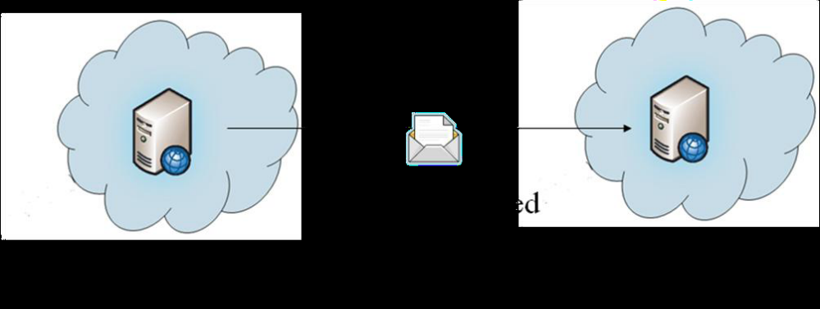
Figure 3 Simple exchange of event messages
This includes what the purpose of all, namely to obtain the incident to the recipient. This corresponds to Message channel as described in [EIP].
An underlying layer of the architecture reflects a more applications and infrastructure close level where event provider is functionally split up into a producer and an incident breaks (Figure 4).
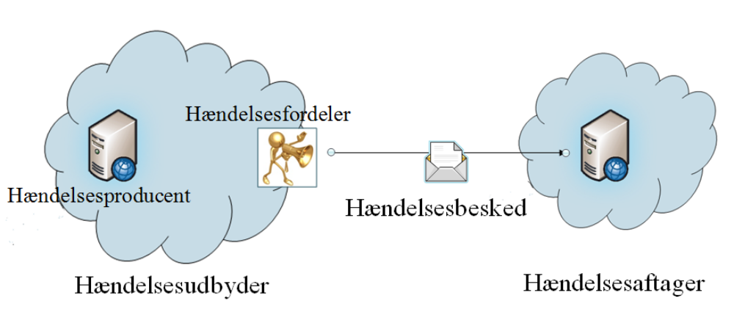
Figure 4 Exchange of event messages over an incident breaks
Using an incident breaks remedied manufacturer to final distribution. The contract for event integration will ever be as shown in Figure 3, but the event provider to technically functionally divided tasks internally without this has no effect on incident juice client.
Here are the most used concepts.
Subscription (Abonnement)
An agreement between a customer event and an event provider, the delivery or access to events from a selected subscription term or topic.
Subscription filter (Abonnementsudtryk)
A logical expression that requires the content. An incident can be distributed based on a subscription expression.
Subscriber (Abonnent)
The subscriber is requesting a subscription and need not be the final event decreases.
Topic (Emne)
An issue is the concept used to categorize incidents and their content.
Topics used as part of the process that determines which event customers to receive an event message. When an event producer creates an event message may be associated with a topic.
Situation (Hændelse)
An incident is any event or logic state change which is known to event producer and potential interest to other parties / applications.
Notification (Hændelsesbesked)
A notification is a concrete message that describes an incident when it must be disseminated from an IT system. An event message is an artifact of the incident, which contains information about incident as an entity wishes to communicate to other entities.
Publisher (Hændelsesproducent )
The one who has access to 'catch' events who is able to translate this for event messages.
NotificationProducer (Hændelsesudbyder)
One, in practice, offers event messages to others, this may be linked directly to event producer or made by another party / application called an incident breaks. For this has no practical significance, because logically they are engaged with one party and should not be know the topology / application architecture with the other party.
NotificationBroker (Hændelsesfordeler)
An event distributor can act in two roles. The first is to distribute event messages to event producers and including the management of subscribers and access. The second role is as event decreases as the gateway for example, for security reasons or for internal distribution.
Notification Customer (Hændelsesaftager)
This is the recipient of the event messages from an event provider.
Event Type(Hændelsestype)
The type of incident, which is represented by a given event message and implicitly defines the content of an incident - either from the specific incident in question, or the content thereof.
Error Message (Fejlbesked)
If a receiving system cannot process an event message because of syntactic or semantic problems (business logic) should send an error message returned so that can be followed up on it (Error Channel from [EIP]).

Usage scenario
To describe how a general incident likely to be used - and the reasoning for the elements included and their use - is in Figure 4 created a scenario in terms of an overall architectural drawing, covering several possibilities.
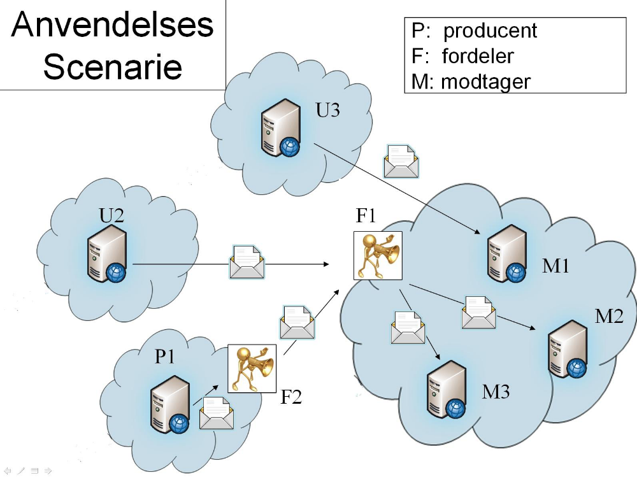
Figure 5 Overall architecture for the application scenario
The goal of the overall incident is creating the possibility that infrastructure relatively easily handle event messages on a logical level - that is not primarily the physical delivery and addressing.
Everything can easily be done without any general event message, but it can sometimes be a little cumbersome and costly.
It is highly incident distributors, who can benefit from the general event message as they are infrastructure components that are not necessarily apply / 'understand' the content of the specific event messages. Figure 5 shows a quite general application scenario:
- Event Producer, P1, detects business event and produces an event. P1 must could not handle the distribution, including subscriptions, any revisit approval of event messages or summaries of the latest incident messages.

- Incident distributor, F2, making the distribution of event messages based on various criteria, for example, rules of sender, event object, topic or the specific type of event.
- Incident distributor, F1, have defined subscriptions on behalf of incident juice client, M2 and M3 and serves as a kind of Application proxy, possibly with additional functionality as message transformation, filtering, protocol transformation, management of safety aspects, etc.
A general event message also makes that defines the specific event messages have a framework that locate general information in.

Chapter 3 WSI-SD - Ringsted Project
Here is a short version of the general event message, which was defined in WSISD project "Incident- Semantics and Schedule "Consultation Draft 1.0 [Haendelse08] (see also Appendix C).

Format of the event message - EventStructure
The general event message has the name EventStructure, and consists of the following elements:
- EventDetailStructure - includes specific event message (business event). EventDetailStructure contains a separate table, defining the structure of the concrete form of a system event or a return event. There can be only included one detailed structure per incident.
- EventIdentificationStructure - eventID are used for identification of an incident.
- Event Registration Date Time - Time of recording: the time when an individual actor or a system operator has activated a feature that stores information. Different from transit time (envelopes) and effective date (event content).
- EventCreatorStructure - general information about the creator of an event, respectively information and also information on creating the organization and / or person.
- EventSenderIdentifier - senderID indicates unique sender name for the last (previous) sender. In the event of an incident comes from an event provider, the provider has completed field. When the incident redistributed Event manifold overwritten element of incident manifold so that it always reflects senderID's in the last (previous) IT system. The item is designed to solve the problem of echo off.
- EventSubscriptionIdentifier (optional) - subscriptionID, identification of the subscription.
The specific incident message is embedded in EventDetailStructure and most elements have a relatively simple content - apart from EventCreatorStructure which has much information richness. It contains organisation both the system that created the incident (event producer) and performing creates in the form of organization as or person, system information, return criterion and possibly. name of the exporting activity (optional) where / by which the incident occurred. Must contain information on the IT system that has formed / Created the event and the organization or person engaged in the publication of the incident. In connection with municipal communities to perform organization differ from responsible organization.

Chapter 4 International standards
There are two competing international standards for supporting Web service based event distribution, which is relevant to a general event message.

Web Services Notification (WSN)
Standard organization OASIS has been responsible for the standardization of Web services Notification, which has its source in GRID computing. The current version is 1.3 from October 2006 [WSN].

Format of the event message
Web Services Notification allows for that event messages sent either directly (raw Notification) or embedded in a general event message wsnt: Notify [WSNXSD1], see Appendix A for this form.
This includes both some metadata (Notification Metadata) and an element for embedding of the specific incident. The format allows you to upload multiple event messages at once. The metadata elements that are defined are:
- SubscriptionReference - A Web Services Addressing EndpointReference for the subscription as associated with the event message. (Valgfri) (Optional)
- Topic - A topic expression that describes just one topic that will be the topic which is affiliated Event message. This element describes the topic that matched the subscription, which was event provider to send event message to hædelsesaftageren. (Valgfri) (Optional).
- Produce Reference - A Web Services Addressing EndpointReference to the event provider which provided the event message. (Valgfri) (Optional)
- Message - (Required)

Webservices Eventing (WSE)
A draft specification for Web Services Eventing was given to the W3C in 2006 with an immediate expectation that it would be finalized by default. There was also briefly a job to get convergence with Web Services Notification - but this failed. Only in 2009, work specification was resumed under the program with webservices Resource Access (WS-RA) [WS-RA] and the timing indicates that the group expects that it will be a pre-standard in the spring of 2010.
Although the specification is not a formal standard, it had no application

Format of the event message
In the current working draft [WSE] (September 24, 2009), the format is specified with a simple wrapper wse:Notify , as briefly shown in appendix B. This is an addition which is made in the current standardization, from a desire to have a general format, called "Event Sink Wrapper" as part of specification.
Wse: Notify is the practice in an element that contains the specific event message and the possibility to set the xml attribute actionURI to indicate what type of event it is in content.
Distribution and support
There is no overview of the application of these standards (for WSE forthcoming). An immediate internet search shows just a rather low degree of implementation in neither existing products, nor any experience in relation to the degree of interoperability of these implementations.

Chapter 5 A general event message
The structure for the format consists of four main elements:
- Signature - Option for specifying a digital signing can be used to check the integrity of both by direct transmission to a receiver or distribution through multiple incident distributers.
- EventInfoStructure - General properties of an event consisting of identifier registration date, event producer, specifying which object incident concerns and which action is undertaken. Here are allowed extensions.
- EventTopic and EventSubscriptionReference - distribution information with the opportunity to indicate what subject it is affiliated and any subscription. There is also room for expansion.
- EventDetailStructure - the specific event.
Figure 6 shows a graphical presentation.
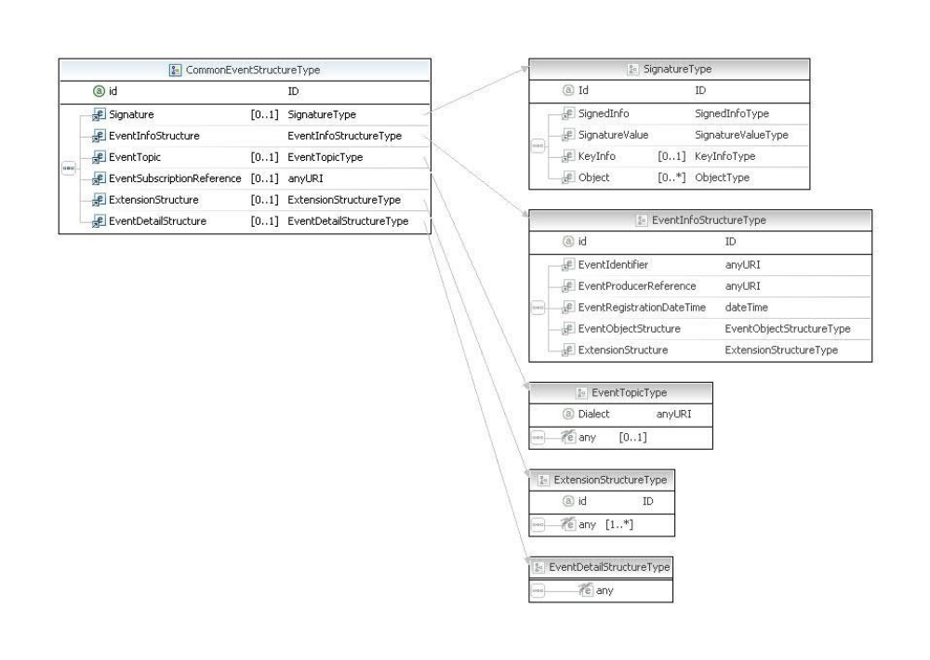 Figure 6 Graphical presentation formats
Here follows a description of individual structures.
CommonEventStructure
Signature | Optional | Possible indication of digital signature
EventInfoStructure | Required | Structure of general attributes that can be redistributed without modification, for example signed.
EventTopic EventTopic | Optional | Directory as the incident is linked. This can be changed during the redistribution and is therefore located outside EventInfoStructure. Can such a classification.
EventSubscriptionReference | Optional | Reference to the subscription offering rise to the distribution of the incident
ExtensionStructure | Optional | This is an open structure to allow to add extensions
EventDetailStructure | Optional | Can contain any specific incident and is an open structure

EventInfoStructure
EventIdentifier | Required | Identifier for the event
EventProducerReference | Required | Reference to the producer of the event
EventRegistrationDateTime | Required | Time when the incident occurred
EventObjectStructure | Required | A structure which indicates which business object, the incident provides
ExtensionStructure | Optional | This is an open structure which can contain any specific incident

EventObjectStructure
ObjectTypeReference | Required | Indication of what type of object in question, e.g. a person, property, case.
EventObjectReference | Required | A reference to the business object, this can either be a pseudonym, a resource or a second structured identifier such as. CVR- CVR No.
actionSchemeReference | optional | Allows specifying udfaldsrum for acts which are not bound to @ObjectTypeReference
EventObjectActionCode | Required | An indication of which action is performed on business object. It can be an act that has changed the status of an object; for instance, update of a relationship where the object is not changing state

EventTopic
Dialect | Optional | Specify the type or classification of subjects used
Value | Required | Enter a topic as the incident is linked
Note that the representation of the term 'reference' is used in several elements and attributes. Use of this is to emphasize that the definition is made somewhere else and it is this definition referenced.
Such a reference can therefore in principle be (to) a CVR number, a URN or URL where possible. Further information is available.

Use of the message format along with WS-Eventing or WS-Notification
In the two web service standards WS-Eventing and WS-Notification is possible either to use an arbitrary format (raw) or use the message format as they themselves define (wrapped). Therefore, the general event message described in this document without problems be used with both standards as raw.

Examples
Here are a few examples (not normative), based on existing examples from [WSISD].
First a simple example, which simply is general information and not a specific incident in: EventDetailStructure:

urn:uuid:3a556b60-3f37-11dc-a2a7-0002a5d5c51b
urn:kmd:system:boligstoette
2001-12-17T09:30:47.0Z

URN:UUID:D80828C6-F609-42BF-94BA-C19B15CD744C
opstaaet

urn:kmd:system:boligstoette:88889999

The next example uses nearly all the elements in the overall event message including a signature (which is not correct):

TCDVSuG6grhyHbzhQFWFzGrxIPE=

SGVqIHZlcmRlbg==

SGVqIHZlcmRlbg==

URN:UUID:086a1ef2-2897-4d98-99fc-6a348b10aad2
http://www.ringsted.dk/system/sogd/
2007-04-04T09:30:47.0Z

URN:UUID:D80828C6-F609-42BF-94BA-C19B15CD744C
opstaaet

urn:uuid:32.06.08
urn:uuid:f81d4fae-7dec-11d0-a765-00a0c91e6bf6

2512484916

PRI

2007-11-01T00:00:00.0Z
opstaaet

0329

18957981

URN:UUID:63ea3b6b-cd26-43e5-a97a-884c8b558d94

16.23.02
G01

References
Here is a list of the sources that are referenced in the document
[WSISD] | Web Service Integration of Case & Document WSISD  http://www.itst.dk/wsisd
[ES] | http://rep.oio.dk/itst.dk/xml/schemas/2007/07/06/itst_eventstructure.xsd
[WSRA] | Web Services Resource Access Working Group  http://www.w3.org/2002/ws/ra/
[WSN] | Web Services Notification (WSN), OASIS Standard in October 2006  http://www.oasis-open.org/specs/index.php#wsn
[WSNXSD1] | XML Schema for Web Services Base Notification 1.3 XML Schema for Web Services Base Notification 1.3  http://docs.oasis-open.org/wsn/b-2.xsd
[WST] | Web Services Topics 1.3 (WS-Topics)  http://docs.oasis-open.org/wsn/wsn-wstopics-1.3-spec-os.htm
[WSE] | Web Services Eventing (WS-Eventing), W3C Working Draft 24 September 2009 http://www.w3.org/TR/2009/WD-ws-eventing-20090924/
[Haendelse08] | Event Semantics and Form, Consultation Draft 1.0 http://www.itst.dk/wsisd/haendelse/haendelse.pdf
[SDREFARK] | "Reference Architecture for case and document area" http://digitaliser.dk/resource/230679
[BPMN11] | Business Process Modeling Notation, V1.1, January 2008 http://digitaliser.dk/resource/323177
[WSEXSD] | Web Services Eventing (WS-Eventing), W3C Working Draft 24 September 2009, Appendix B XML Schema  http://www.w3.org/TR/2009/WD-ws-eventing-20090924/#Schema
[SOGDGEN] | General characteristics of services on the file and document area http://digitaliser.dk/resource/444163/artefact/Generelle+egenskaber+for+services+p%c3%a5+sags-+og+dokumentomr%c3%a5det+-+OIO-Godkendt.pdf
[WSBAN] | Web Services Base Notification 1.3 (WS-BaseNotification)  http://docs.oasis-open.org/wsn/wsn-ws_base_notification-1.3-spec-os.htm
[WSBRN] | Web Services Broker Notification 1.3 (WS-BrokeredNotification)  http://docs.oasis-open.org/wsn/wsn-ws_brokered_notification-1.3-spec-os.htm

Other relevant references
[WSA] | Web Services Addressing 1.0 - Core  http://www.w3.org/TR/ws-addr-core/  Web Services Addressing 1.0 - SOAP Binding  http://www.w3.org/TR/ws-addr-soap/  Web Services Addressing 1.0 - WSDL Binding  http://www.w3.org/TR/ws-addr-wsdl/
[WSISD-EDA] | Event-Oriented Architecture  http://www.itst.dk/arkitektur-og-standarder/Standardisering/datastandardisering/tvergaende-sags-og-dokumenthandtering/projekt-ws-i-sd/ws-is-d-dokumentoversigt/loesning/haendelsesorienteret_arkitektur.pdf
[WSISD-AH] | Subscription Manager http://www.itst.dk/wsisd/forretningsregler/abonnementshaandtering.pdf

Appendix A – XML Schema for WSN
This is described in [WSBAN] and [WSNXSD1]
http://docs.oasis-open.org/wsn/b-2.xsd
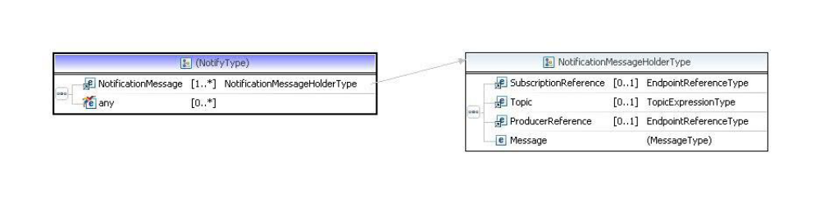
<!-- ================= Notification Metadata ===================== -->
<xsd:element name="SubscriptionReference" type="wsa:EndpointReferenceType" />
<xsd:element name="Topic" type="wsnt:TopicExpressionType" />
<xsd:element name="ProducerReference" type="wsa:EndpointReferenceType" />
<!-- ================== Message Helper Types ===================== -->
<xsd:complexType name="NotificationMessageHolderType" >
<xsd:sequence>
<xsd:element ref="wsnt:SubscriptionReference" minOccurs="0" maxOccurs="1" />
<xsd:element ref="wsnt:Topic" minOccurs="0" maxOccurs="1" />
<xsd:element ref="wsnt:ProducerReference" minOccurs="0" maxOccurs="1" />
<xsd:element name="Message">
<xsd:complexType>
<xsd:sequence>
<xsd:any namespace="##any" processContents="lax" minOccurs="1" maxOccurs="1"/>
</xsd:sequence>
</xsd:complexType>
</xsd:element>
</xsd:sequence>
</xsd:complexType>
<xsd:element name="NotificationMessage" type="wsnt:NotificationMessageHolderType"/>

<!-- ========== Message Types for NotificationConsumer =========== -->
<xsd:element name="Notify" >
<xsd:complexType>
<xsd:sequence>
<xsd:element ref="wsnt:NotificationMessage" minOccurs="1" maxOccurs="unbounded" />
<xsd:any namespace="##other" processContents="lax" minOccurs="0" maxOccurs="unbounded"/>
</xsd:sequence>
</xsd:complexType>
</xsd:element>
Appendix B - Proposed XML Schema for WSE
This can be seen in [WSEXSD] as currently http://www.w3.org/TR/2009/WD-ws-eventing-20090924/#Schema

Appendix C - Proposal by [Haendelse08]
This is partly described in [Haendelse08] and the form [ES]. It can be downloaded in the past was ISBens repository.
http://rep.oio.dk/itst.dk/xml/schemas/2007/07/06/itst_eventstructure.xsd
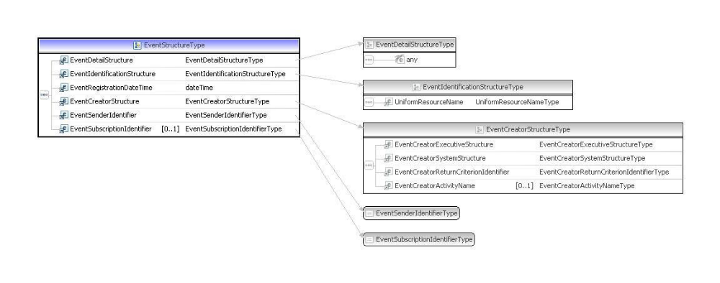
<?xml version="1.0" encoding="UTF-8"?>
<schema xmlns=http://www.w3.org/2001/XMLSchema xmlns:itst="http://rep.oio.dk/itst.dk/xml/schemas/2007/07/06/" targetNamespace="http://rep.oio.dk/itst.dk/xml/schemas/2007/07/06/" elementFormDefault="qualified">
<include schemaLocation="http://rep.oio.dk/itst.dk/xml/schemas/2007/07/06/ITST_EventDetailStructure.xsd"/>
<include schemaLocation="http://rep.oio.dk/itst.dk/xml/schemas/2007/07/06/ITST_EventIdentificationStructure.xsd"/>
<include schemaLocation="http://rep.oio.dk/itst.dk/xml/schemas/2007/07/06/ITST_EventRegistrationDateTime.xsd"/>
<include schemaLocation="http://rep.oio.dk/itst.dk/xml/schemas/2007/07/06/ITST_EventCreatorStructure.xsd"/>
<include schemaLocation="http://rep.oio.dk/itst.dk/xml/schemas/2007/07/06/ITST_EventSenderIdentifier.xsd"/>
<include schemaLocation="http://rep.oio.dk/itst.dk/xml/schemas/2007/07/06/ITST_EventSubscriptionIdentifier.xsd"/>
<element name="EventStructure" type="itst:EventStructureType"/>
<complexType name="EventStructureType">
<sequence>
<element ref="itst:EventDetailStructure"/>
<element ref="itst:EventIdentificationStructure"/>
<element ref="itst:EventRegistrationDateTime"/>
<element ref="itst:EventCreatorStructure"/>
<element ref="itst:EventSenderIdentifier"/>
<element ref="itst:EventSubscriptionIdentifier" minOccurs="0"/>
</sequence>
</complexType>
</element>
</schema>

